INSTALL

* Install Firefox [www.mozilla.com/en-US/firefox/fx](http://www.mozilla.com/en-US/firefox/fx)/
* Install PSPAdText www.pspad.com/en/download/php
* Installing XAMPP <http://www.apachefriends.org/en/xampp-windows.html> Contains Apache and PHP

**PSPAD Editor**

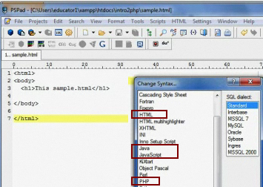

Installing XAMPP

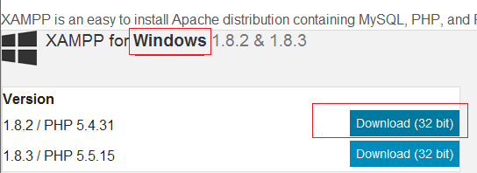

Create folder **C:\PHP\xampp**

Download in **C:\PHP\xampp**

Unzip and run **setup_xampp.bat**

Verify installation

* Run xampp-control.exe
* Start Apache server

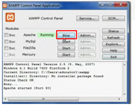

open browser and type <http://127.0.0.1> or localhost it will show

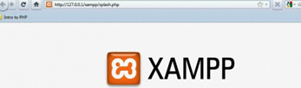

<http://127.0.0.1/xampp> is known as the loopback IP, start apache also with **http://localhost/**

**Document Root**

* Folder where files accessible via a webserver are stored
* C:\PHP\axmpp\htdocs
* En .NET es C:\InetPub\wwwroot
* http://127.0.0.1/xampp/start.php http://localhost/xampp/start.php
* If you are not sure, search where the index.php file is

**CONFIGURATION FILE** C:\PHP\xampp/php/php.ini

To configure short tags

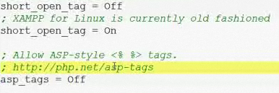

The phpinfo() is used to check the current configuration, create a program



When running program

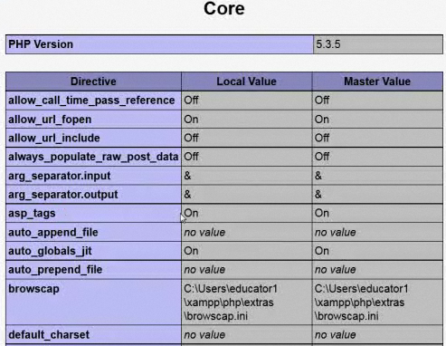

**TROUBLESHOOT**

TO MAKE APACHE / ORACLE /IIS TOGETHER CHANGE APACHE TO PORT 8080 INSTEAD 80

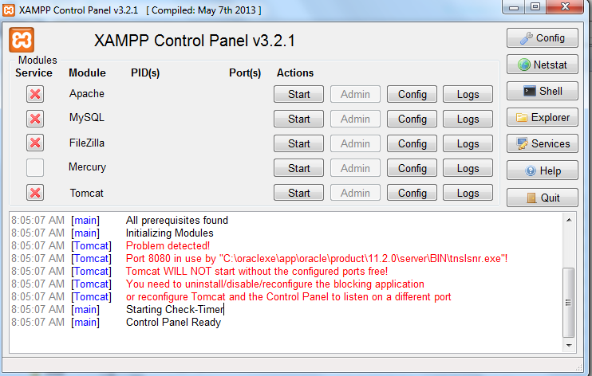

C:\PHP\xampp\tomcat\conf\server.xml

Change port 8080

<Connector port="8081" protocol="HTTP/1.1"

connectionTimeout="20000"

redirectPort="8443" />

<!-- A "Connector" using the shared thread pool-->

<!--

<Connector executor="tomcatThreadPool"

port="8081" protocol="HTTP/1.1"

connectionTimeout="20000"

redirectPort="8443" />

Now run the files with

C:\**xampp\apache\conf\ httpd.conf**

Comente

**#LoadModule ssl_module modules/mod_ssl.so**

A Puerto 8080

**Listen 8080**

**ServerName localhost:8080**

Useful links

<http://www.php.net/manual/en/install.php>

<http://httpd.apache.org/docs/2.2>

**http://127.0.0.1/xampp/[file].php**